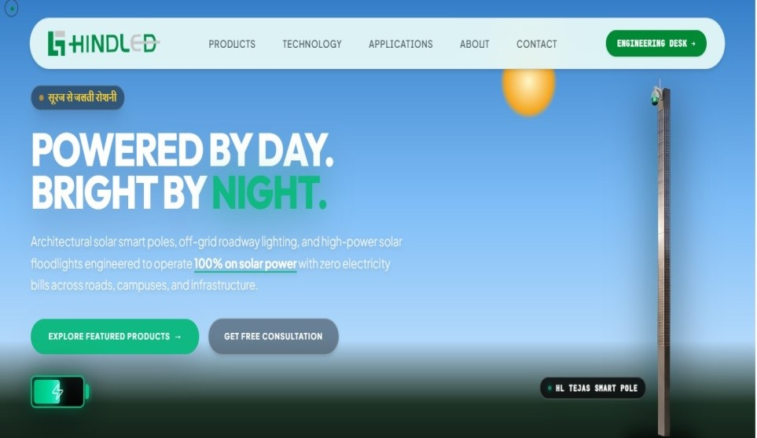
** Hindi to English
1. Beyond efficiency total energy independence

**Sun location as per discussed

**ADITI home page product

**lines below the title “Powered by days Bright by night” lines
“Make the shift from energy efficiency to complete energy independence our company range of solar street light architectural smart poles and off grid roadway lighting operates 100% on solar power eliminating electricity bills for modern infrastructure.”

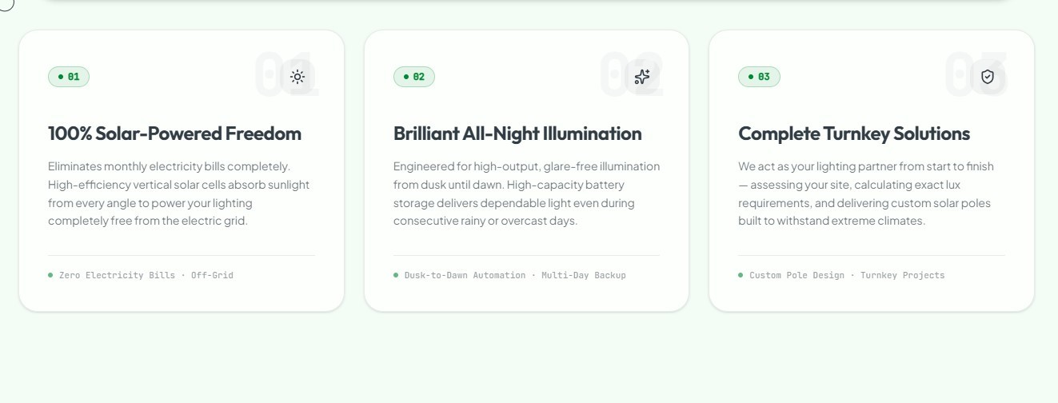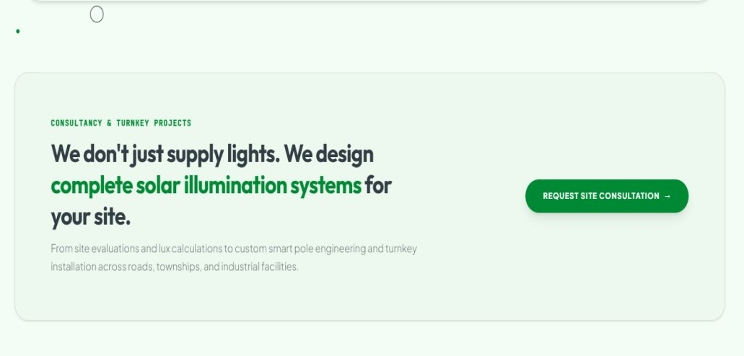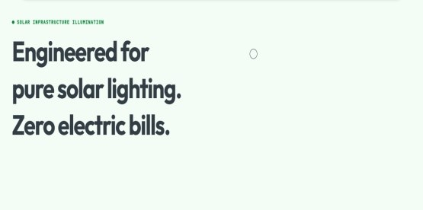

**Font size should be proportionate
**Font bold, dark and visible
**noted : use only two 2 types of font style.

**
Numbers graphics either one keeping the number only on right side

Low glare everywhere
**glare free

**Site Project
**Custom solar poles customized lighting solution
**Site

Project

Customized engineering

** Custom smart pole engg.

solution
** add word after township ,”Landscapes”.
**facilities Projects.
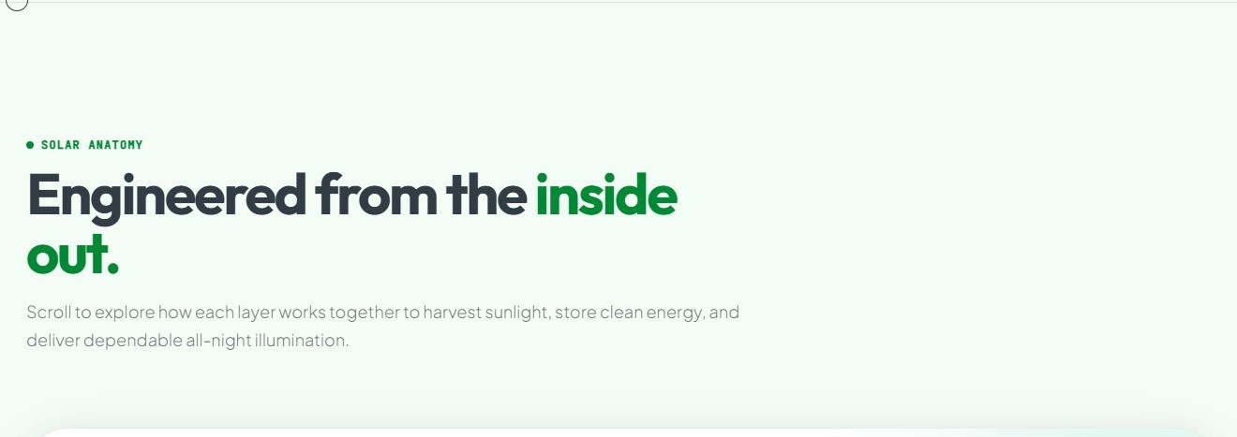**all correct
**Entire word to be removed
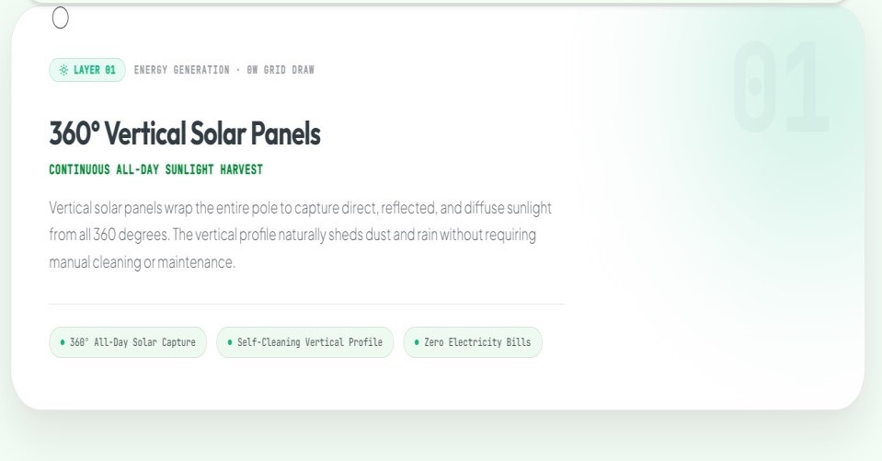
**Marine grade die cast aluminum alloy paired with high impact… instead write the material provided in the catalogue i.e. aluminium 6063
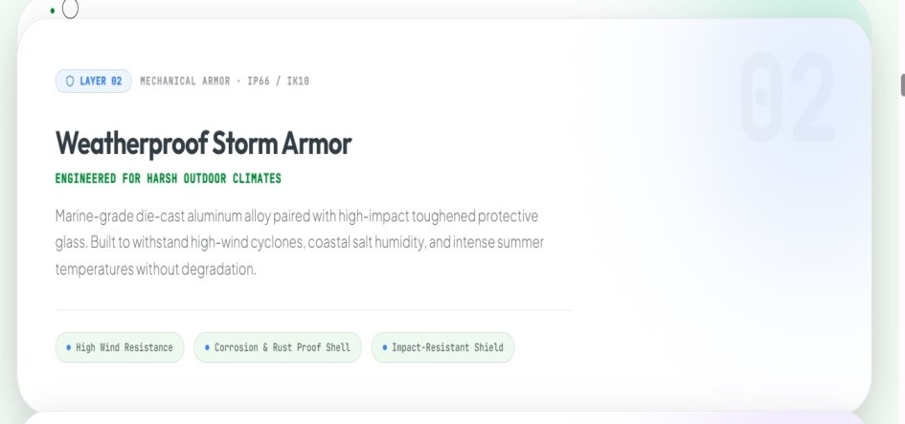

** all correct
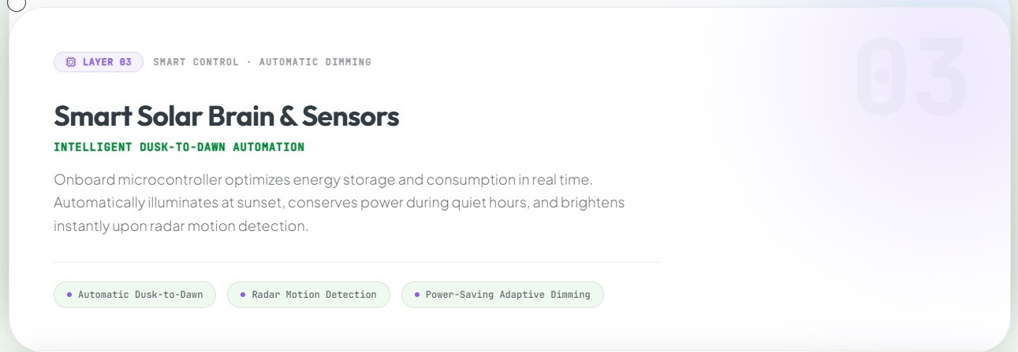

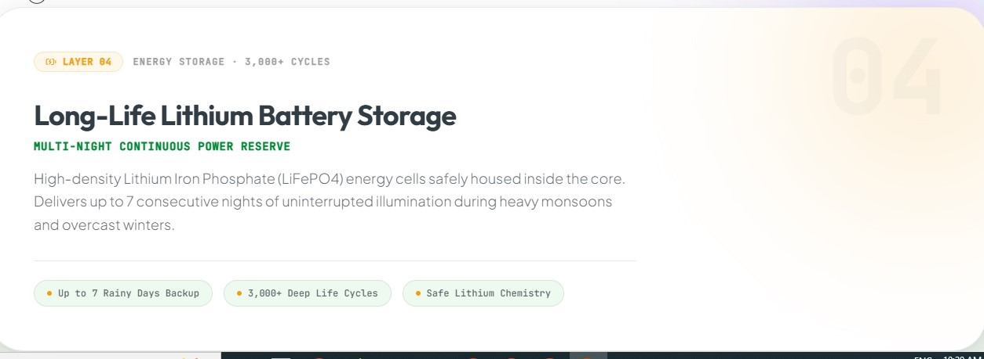
**3 consecutive nights instead of 7 ( to be changed at 2 places)

**Low glare (mentioned twice)
** precision optical lenses designed to ensure high luminaire led (first line change)
**No dark spots instead of zero dark spots
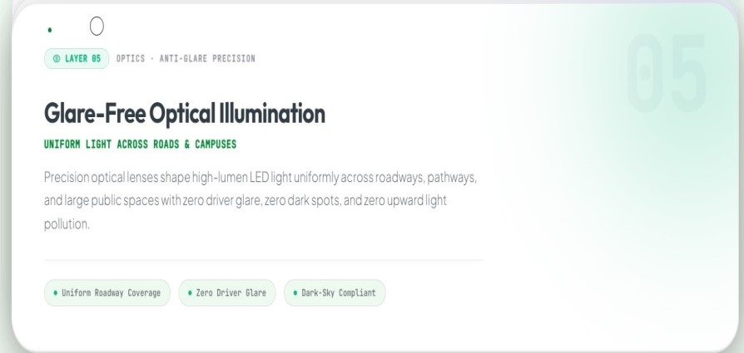
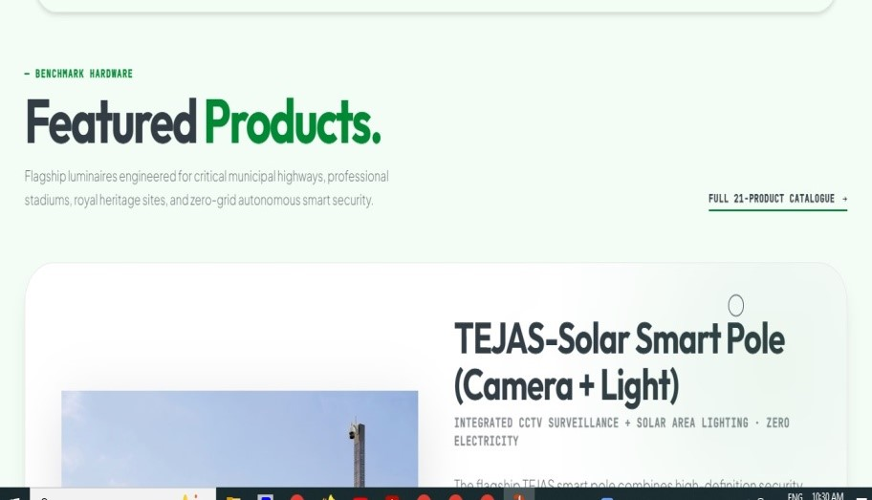 | The description under featured products to be changed into simplier language.
  **HL (REMOVE) everywhere
  **30W TO 150W
  **Robust, die cast aluminium housing with an Aerodynamic design that reduce wind resistance and facilitates rainwater runoff with integrated high capacity lithium batteries, MPPTs and optical sensors. (change the paragraph
  **100% solar powered lighting instead of zero grid
  **High efficiency of optics 160-170lm/w with customized optical distribute and diversify roadway application. Instead of high efficiency roadway
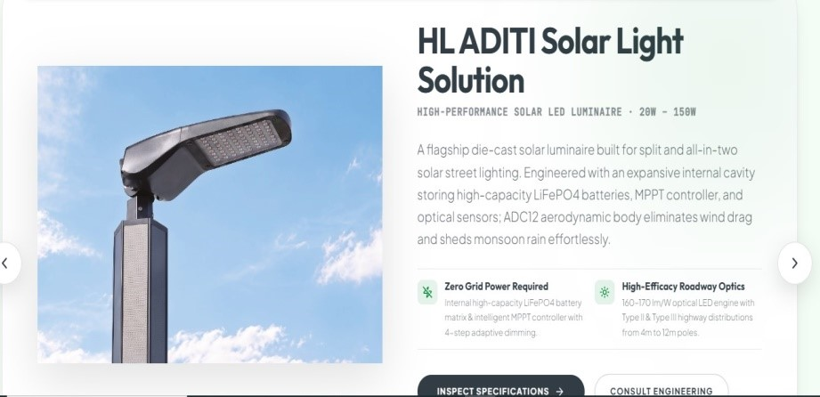
**"only Camera “
Please make a note and change everywhere.
** remove the word garden from heading
**"Timeless aesthetic solar garden luminaire inspired by classic lantern forms brings refined elegance to outdoor spaces available with lenses to Improve light distribution and enhance ambience. idol for gardens, architectures, landscape , plaza, residential states."
**low glare
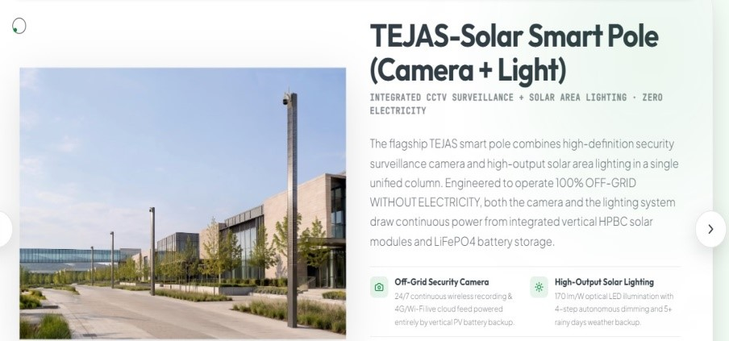
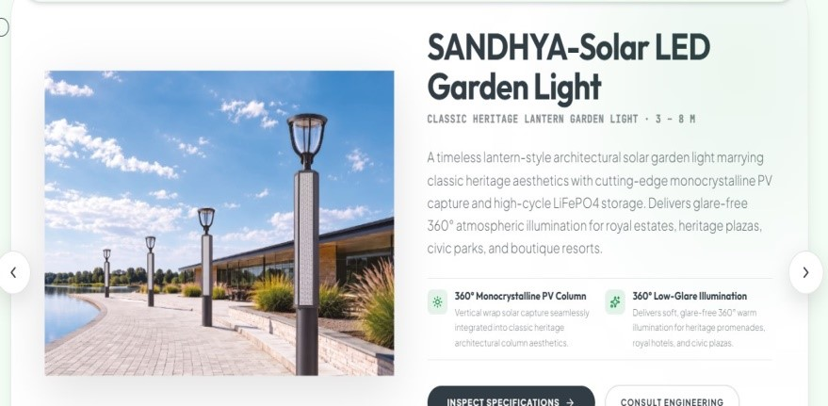
Inspect specification
Add+ C3 Anodized word to be removed

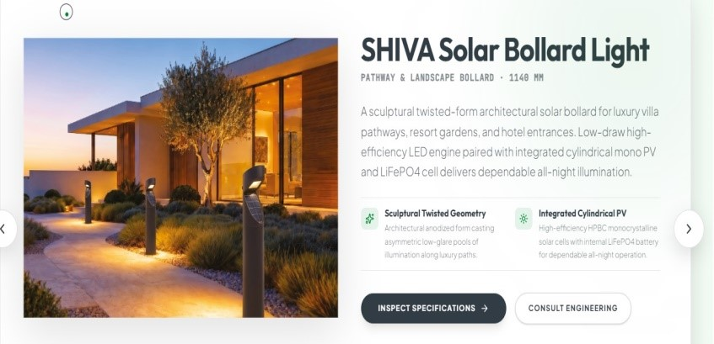

- "Flagship lens for architectural lens facade lighting to design to Create distinctive wall washing effects with adjustable optics for Versatile illumination of build and architectural surfaces." (paragraph)
- "Linear 20w Solar Luminaire with selectable wide, medium, and narrow optics options Integrated" (specification on the right)

**1000mm or 1m Linear

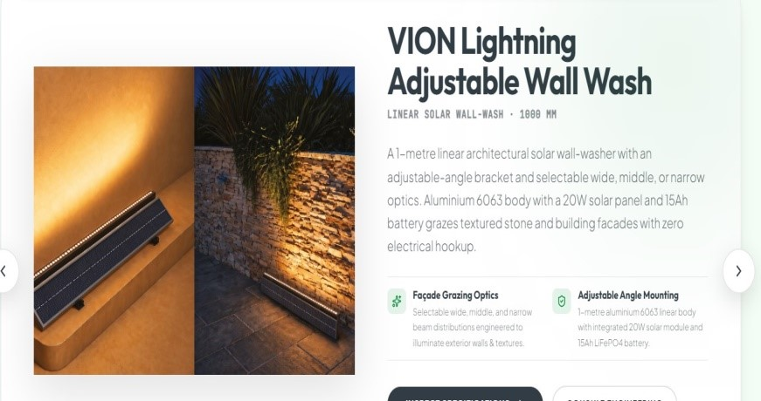

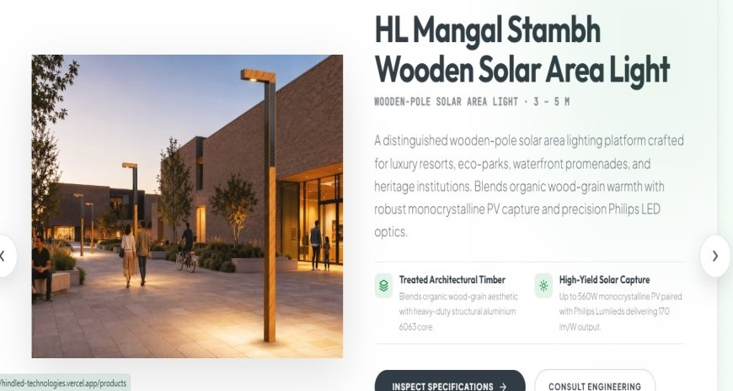
**HL
** PHILIPS
** WOODEN AND ALUMINIUM WRITE AS A
OPTIONAL WE PROVIDED
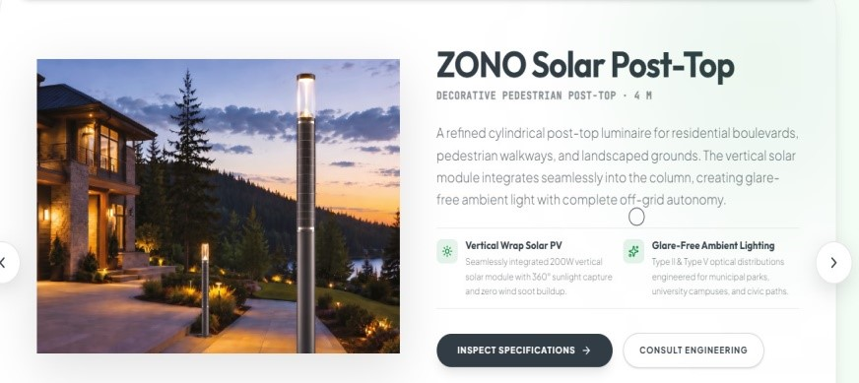
**Premium Ped. Instead of Post top
Reference lines- Aesthetic Combines with Integrated Solar PV module for LED Suitable outdoor illumination.
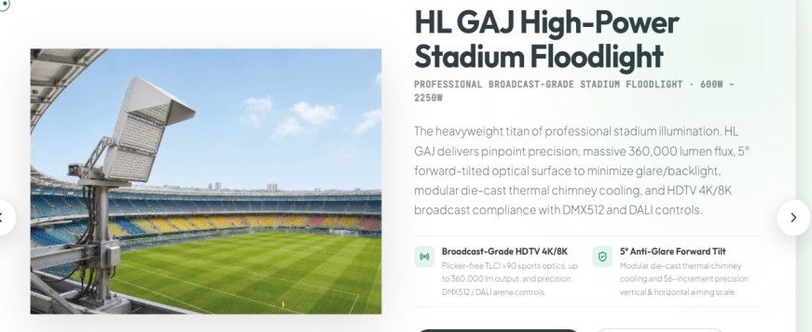
Glare free to be low glare
REMOVE HL Rewrite in simple : (mentioning important points)
Tatium professional sports and stadium flood lighting, high performance. LED flood for demanding output application.
Lights engineered for professional sports facilities, stadium and large outdoor areas

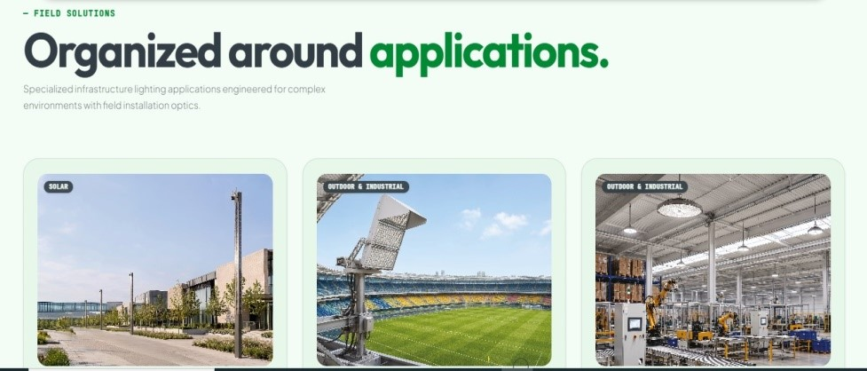
Remove (repeated)
Additionally remove chief executive page about Mr. brij Bhatia from the home page
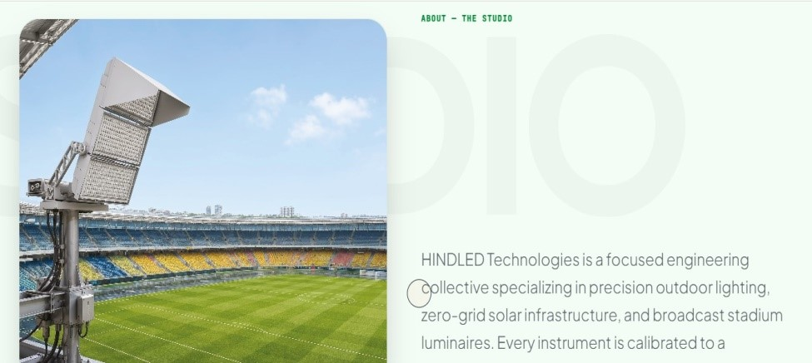
Add Aditi image

